ELECTRIC POWER PLANT

UMUM
Electric Power Plant dibagi dalam sistem konfigurasi sebagai berikut :
- 440 V / 60 Hz
- 230 V / 60 Hz
- 230 V / 60 Hz UPS
- 115 V / 60 Hz
- 115 V / 400 Hz
- 24 VDC

A. Konfigurasi 440 V / 60 Hz :
Dibagi lagi menjadi :

a. Electric Power Generation :
3110-A0001 | DG PS FWD, dihubungkan dengan pesawat bantu
3110-A0002 | DG SB FWD, dihubungkan dengan pesawat bantu
3110-A0003 | DG PS AFT, dihubungkan dengan pesawat bantu
3110-A0004 | DG SB AFT, dihubungkan dengan pesawat bantu
3110-A0005 | Emergency Diesel Generator (EMDG), dihubungkan dengan pesawat bantu

b. 440 V / 60 Hz Power Distribution :
Yang berisi komponen – komponen utama sebagai berikut :
3241-E5001 | MSB AFT
3241-E5002 | MSB FWD
3241-E5003 | ESB
3241-E5004 | SHORE
3241-E5005 | DP 440 V AFT
3241-E5006 | DP 440 V FWD
3241-E5007 | DP 440 V ER PS
3241-E5008 | DP 440 V ER SB
3241-E5009 | DP 440 V MSB AFT
3241-E5010 | DP 440 V MSB FWD
3241-E5013 | DP 440 V LAUNDRY
3241-E5021 | DP 440 V / 230 V GALLEY
3241-E5031 | MCC ER
3241-E5032 | MCC DGR
3241-E5033 | MCC FAN PS
3241-E5034 | MCC FAN SB
2341-E5001 | ME PS AUX STARTER PANEL
2341-E5002 | ME SB AUX STARTER PANEL
B. Konfigurasi 230 V / 60 Hz
Yang berisi komponen – komponen utama sebagai berikut :

3243-E5001 | TRAFO 440 / 400 / 230 V 125 KVA AFT
3243-E5002 | MDP 230 V AFT
3243-E5003 | TRAFO 440 / 400 / 230 V 125 KVA FWD
3243-E5004 | MDP 230 V FWD
3243-E5005 | DP 230 V NAV / NAUT
3243-E5012 | DP 230 V 02
3243-E5013 | DP 230 V 03
3243-E5014 | DP 230 V 04
3243-E5015 | DP 230 V 05
3243-E5016 | DP 230 V 06
3243-E5017 | DP 230 V 07
3243-E5018 | DP 230 V 08
3243-E5019 | DP 230 V 09
3243-E5020 | DP 230 V 10
3243-E5021 | DP 230 V 11
3243-E5022 | DP 230 V 12
3243-E5031 | TRAFO 440 / 400 / 230 V 24 KVA EM
3243-E5032 | EMDP 230 V
3243-E5033 | EDP 230 V 01
3243-E5034 | EDP 230 V 02

C. Konfigurasi 230 V / 60 Hz UPS
Yang berisi komponen – komponen utama sebagai berikut :

3133-E5001 | UPS After 3 ph 440 V, 3 ph + neutral 400 V / 230 V 8 KVA 30 menit
3133-E5002 | DP 230 V UPS AFT
3133-E5005 | Selection Change Over Switch UPS After
3133-E5011 | UPS Forward 3 ph 440 V, 3 ph + neutral 400 V / 230 V 8 KVA 15 menit
3133-E5012 | DP 230 V UPS FWD
3133-E5021 | UPS Bridge Area 3 ph 440 V, 3 ph + neutral 400 V / 230 V 8 kVA 15 menit
3133-E5022 | DP 230 V UPS Bridge
3133-E5023 | Selection Change Over Switch UPS Bridge Area
3133-E5102 | DP 115 V UPS
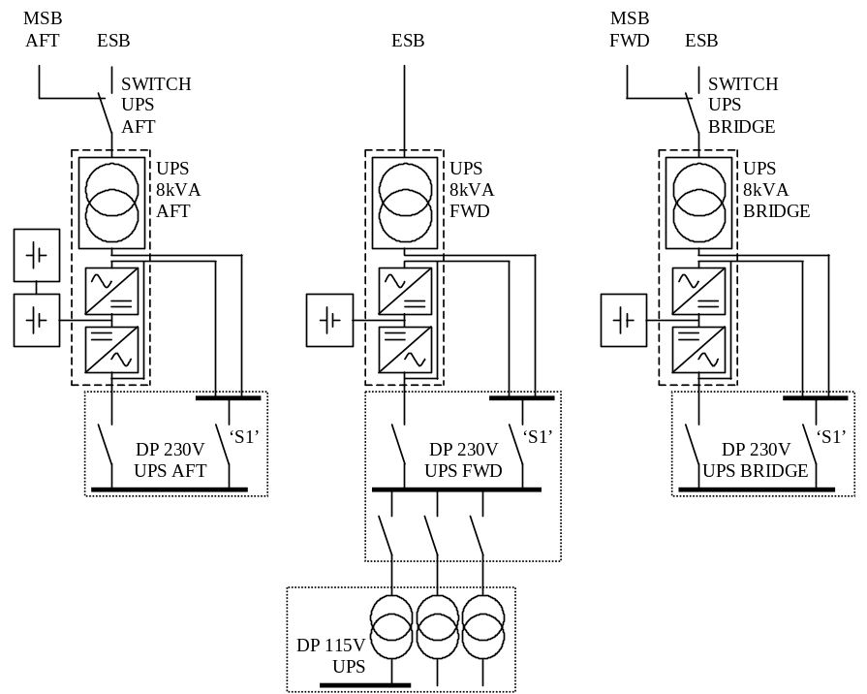
Figure 1 Configuration of 230V/60Hz UPS distribution

D. Konfigurasi 115 V / 60 Hz
Yang berisi komponen – komponen utama sebagai berikut :
3244-E5001 | TRAFO PS 3 ph 440 V, 3 ph 115 V 80 Kva
3244-E5002 | MDP 115 V PS
3244-E5003 | TRAFO SB 3 ph 440 V, 3 ph 115 V 80 kVA
3244-E5004 | MDP 115 V SB
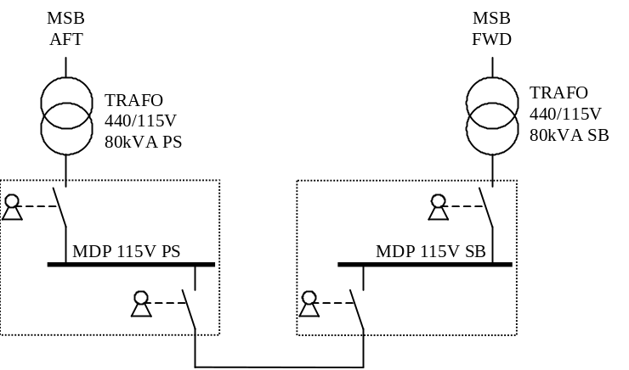
Figure 2 Configuration of 115V/60Hz distribution

E. Konfigurasi 115 V / 400 Hz
Yang berisi komponen – komponen utama sebagai berikut :
3245-E5001 | 115 V 400 Hz Main Gun, 1 ph + neutral 115 V 2kVA
3245-E5002 | DP 400 Hz Synchro Signal
3245-E5003 | Selection Change Over Switch 115 V 400 Hz Syncro Signal
3245-E5006 | Selection Change Over Switch 115 V 400 Hz Main Gun
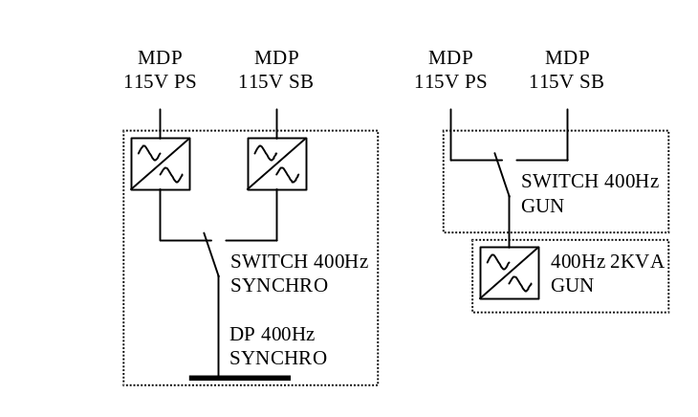

F. Konfigurasi 24 VDC
Yang berisi komponen – komponen utama sebagai berikut :
3242-E5001 | Rectifier / Battery Charger AFT 3 ph 440 V, 2 ph 24 VDC 100 A
3242-E5002 | Battery AFT 24 VDC 350 A
3242-E5003 | Battery Fuse Aft
3242-E5004 | DP AFT 24 VDC
3242-E5008 | Selection Change Over Switch AFT 24 VDC
3242-E5011 | Rectifier / Battery Charger FWD1 3 ph 440 V, 2 ph 24 VDC 100 A
3242-E5012 | Battery FWD 24 VDC 350 A
3242-E5013 | Battery Fuse Forward
3242-E5014 | DP FWD 24 VDC
3242-E5016 | Rectifier / Battery Charger FWD2 3 ph 440 V, 2 ph 24 VDC 100 A (FFBNW)
3242-E5021 | Rectifier / Battery Charger BRD1 3 ph 440 V, 2 ph 24 VDC 100 A
3242-E5022 | Battery Bridge Area 24 VDC 350 A
3242-E5023 | Battery Fuse Bridge Area
3242-E5024 | DP Bridge Area 24 VDC
3242-E5025 | Rectifier / Battery Charger BRD2 3 ph 440 V, 2 ph 24 VDC 100 A
3242-E5027 | DP EER PS 24 VDC
3242-E5028 | DP EER SB 24 VDC
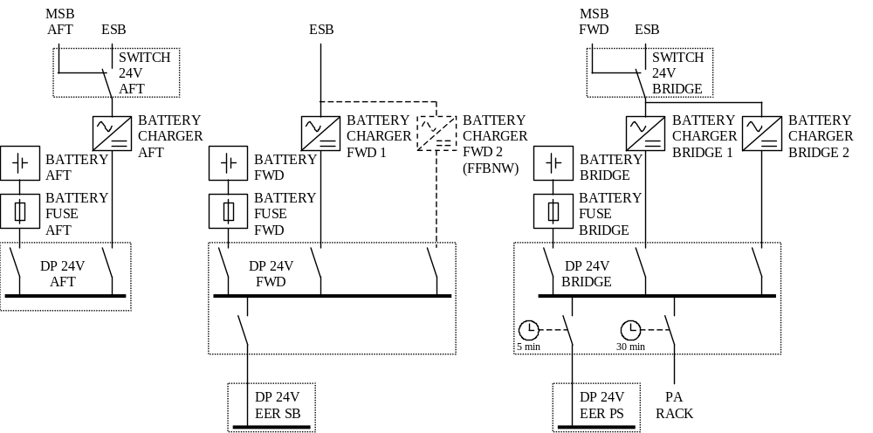

G. 24 VDC Starting System Emergency Diesel Generator Set

24 VDC Power Supply untuk sistem starting Emergency Diesel Generator terdiri dari komponen utama yang terdiri :

3120-E5001 | Start Batteries 24 VDC 280 A1
3120-E5001 | Battery Charger 1 2ph 24 VDC 50 A
3120-E5001 | Start Batteries 24 VDC 280 A 2
3120-E5001 | Battery Charger 2 2ph 230 V, 2ph 24 VDC 50 A
3120-E5001 | EG Battery Switch Panel

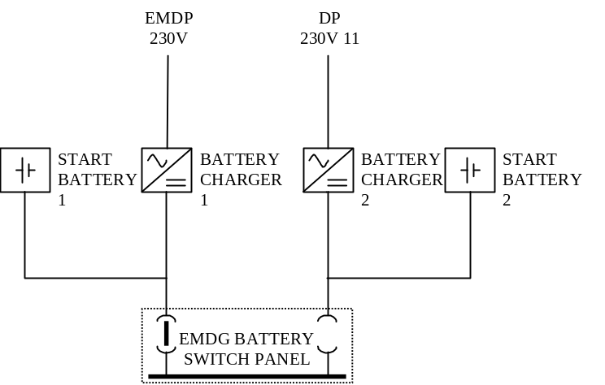

H. Miscellaneous

a. Flight Deck Lighting
Terdiri dari komponen utama yang terdiri :
4223-E5001 | Control Panel Flight Deck Office
4223-E5011 ...E5018 | Horizon Bar Light
4223-E5151 ...E5153 | Horizon Bar Light
4223-E5021 ...E5028 | Flight Deck Floodlight
4223-E5031 | Stop and Go Light
4223-E5032 | Stop and Go Light
4223-E5041 | Homing Beacon

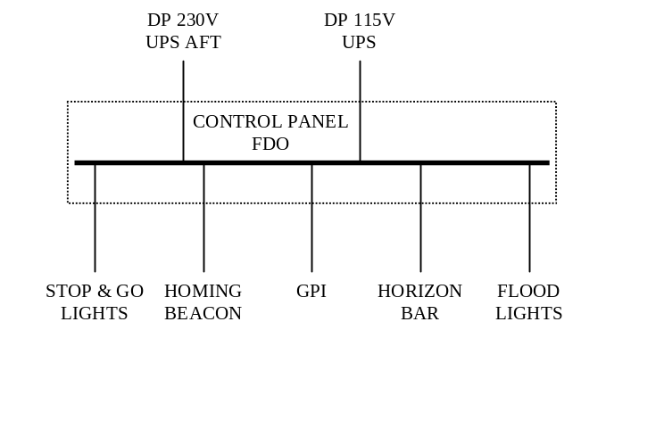

Konfigurasi 440 V / 60 Hz MAIN SWITCH BOARD AFT
Item number : 3241-E5001
Kompartement : 3084 (Switchboard Room Aft MCR / DCHQ)

INCOMING  POWER SUPPLY | KETERANGAN | OUTGOING  FEEDERS | KETERANGAN
3110-A0003 | DG PS AFT | 2331-E5001 | ME PS AUX STARTER PANEL
3110-A0004 | DG SB AFT | 2410-A0001 | ME GEARBOX PS
3241-E5002 | MSB FWD | 3241-E5002 | MSB FWD
3241-E5004 | Shore Supply Box | 3241-E5003 | ESB
3243-E5015 | DP 230 V 05 (Anti Condensation Heating) | 3241-E5005 | DP 440 V AFT
3133-E5002 | DP 230 V UPS AFT | 3241-E5007 | DP 440 V ER PS
 |  | 3241-E5009 | DP 440 V MSB AFT
 |  | 3241-E5013 | DP 440 V LAUNDRY
 |  | 3241-E5021 | DP 440 V / 230 V GALLEY
 |  | 3241-E5031 | MCC ER
 |  | 3241-E5033 | MCC Ventilation PS
 |  | 3243-E5001 | TRAFO AFT 3ph 440 V, 3ph + neutral 400 V / 230 V 125 kVA
 |  | 3244-E5001 | TRAFO PS 3ph 440 V, 3ph 115 V 80 kVA
 |  | 4750-E5002 | Degausing Panel
 |  | 4610-E0001 | Transmitter TXU Cabinet
 |  | 5161-A0002 | AC Chiller Unit 2
 |  | 5610-E0001 | Motor Controller Steering Gear
 |  | 7010-E0001 | Gun Console

Konfigurasi 440 V / 60 Hz MAIN SWITCH BOARD FWD
Item number : 3241-E5002
Kompartement : 3063 (Switchboard Room FWD)

INCOMING  POWER SUPPLY | KETERANGAN | OUTGOING  FEEDERS | KETERANGAN
3110-A0001 | DG PS FWD | 2331-E5002 | ME SB AUX STARTER PANEL
3110-A0002 | DG SB FWD | 2410-A0002 | ME GEARBOX SB
3241-E5001 | MSB AFT | 3241-E5001 | MSB AFT
3243-E5016 | DP 230 V UPS FWD | 3241-E5003 | ESB
3133-E5012 | DP 230 V 06 (Anti Condensation Heating) | 3241-E5006 | DP 440 V FWD
 |  | 3241-E5008 | DP 440 V ER SB
 |  | 3241-E5010 | DP 440 V MSB FWD
 |  | 3241-E5032 | MCC Engine Room
 |  | 3241-E5034 | MCC Ventilation SB
 |  | 3243-E5003 | TRAFO FWD 3ph 440 V, 3ph + neutral 400 V / 230 V 125 kVA
 |  | 3244-E5003 | TRAFO SB 3ph 440 V, 3ph 115 V 80 kVA
 |  | 4610-E0001 | Transmitter TXU Cabinet
 |  | 4750-E5002 | TRAFO PS 3ph 440 V, 3ph 115 V 80 kVA
 |  | 5161-A0001 | Degausing Panel
 |  | 5322-A0001 | AC Chiller Unit 1
 |  | 5160-E0003 | Motor Controller Steering Gear
 |  | 7010-E0001 | Gun Console

Konfigurasi 440 V / 60 Hz EMERGENCY SWITCH BOARD
Item number : 3241-E5003
Kompartement : 5055 (EMERGENCY DG ROOM)

INCOMING  POWER SUPPLY | KETERANGAN | OUTGOING  FEEDERS | KETERANGAN
3120-A0005 | EMDG | 3120-E5003 | JW Panel Emergency DG
3241-E5001 | DG SB AFT | 3133-E5003 | Input TRAFO UPS AFT
3241-E5002 | MSB FWD | 3133-E5014 | Input TRAFO UPS FWD
3120-E5005 | Emergency Gen Battery Switc Panel | 3133-E5024 | Input TRAFO UPS Bridge Area
3243-E5022 | DP 230 V 12 (Anti Condensation Heating) | 3241-E5032 | Starter Emergency Bilge Pump
 |  | 3242-E5001 | Rectifier / Battery Charger AFT 3ph 440 V, 2ph 24 VDC 100 A
 |  | 3242-E5011 | Rectifier / Battery Charger FWD 3ph 440 V, 2ph 24 VDC 100 A
 |  | 3242-E5021 | Rectifier / Battery Charger BRG 3ph 440 V, 2ph 24 VDC 100 A
 |  | 3243-E5031 | Emergency TRAFO 3ph 440 V, 3ph + neutral 400 / 230 V 24 kVA
 |  | 4510-A0002 | Hydraulic Power Unit
 |  | 4510-A0003 | SACU (Wave Guide Drier, Manifold, Sensor)
 |  | 5161-A1017 | Fan Coil FC-1
 |  | 5161-A0019 | Fan Coil FC-3
 |  | 5511-A0001 | Starting Air Compressor 1
 |  | 5551-E5003 | Starter FiFi Pump 3
 |  | 5552-E0003 | Module Cabinet Fix. Loc. Appl.
 |  | 5610-E0002 | Motor Controller Steering Gear
 |  | 5610-E0004 | Motor Controller Steering Gear
 |  | 5834-E0005 | Deck Crane PS
 |  | 6650-A0012 | Test Panel

Konfigurasi 440 V / 60 Hz SHORE CONNECTION BOX
Item number : 3241-E5004
Kompartement : 4091 (Boat Gear Store / Awning Store)

INCOMING  POWER SUPPLY | KETERANGAN | OUTGOING  FEEDERS | KETERANGAN
3241-E5001 | MSB AFT | 3241-E5001 | MSB AFT
3243-E5014 | DP 230 V 04 (Anti Condensation Heating)

DISTRIBUTION PANEL 440 V
NO | NAMA | ITEM  NUMBER | COMPT | INCOMING POWER SUPPLY | OUTGOING FEEDERS  REFERS TOTABLE
1 | DP 440 V MSB AFT | 3241-E5009 | 3081 | 3241-E5001 MSB AFT | 190134-3241-E5009-GVL (Appendix A)
2 | DP 440 V MSB FWD | 3241-E5010 | 3061 | 3241-E5002 MSB FWD | 190134-3241-E5010-GVL (Appendix A)
3 | DP 440 V AFT | 3241-E5005 | 3111 | 3241-E5001 MSB AFT | 190134-3241-E5005-GVL (Appendix A)
4 | DP 440 V FWD | 3241-E5006 | 3031 | 3241-E5002 MSB FWD | 190134-3241-E5006-GVL (Appendix A)
5 | DP 440 V ER PS | 3241-E5007 | 1071 | 3241-E5001 MSB AFT | 190134-3241-E5007-GVL (Appendix A)
6 | DP 440 V ER SB | 3241-E5008 | 1071 | 3241-E5002 MSB FWD | 190134-3241-E5008-GVL (Appendix A)
7 | DP 440 V LAUNDRY | 3241-E5013 | 3114 | 3241-E5001 MSB AFT | 190134-3241-E5013-GVL (Appendix A)
8 | DP 440 V – 230 V GALLEY | 3241-E5021 | 1071 | 3241-E5001 MSB AFT  3241-E5002 MDP 230 V AFT | 190134-3241-E5021-GVL (Appendix A)
9. | MCC ER | 3241-E5031 | 1071 | 3241-E5001 MSB AFT  3241-E5015 DP 230 V 05 Ant Cond H | 190134-3241-E5031-GVL (Appendix A)
10. | MCC DGR | 3241-E5032 | 1061 | 3241-E5002 MSB FWD  3241-E5003 ESB  3241-E5016 DP 230 V 06 | 190134-3241-E5032-GVL (Appendix A)
11. | MCC FAN PS | 3241-E5033 | 4073 | 3241-E5001 MSB AFT  3241-E5016 DP 230 V 06 | 190134-3241-E5033 (Appendix A)
12. | MCC FAN SB | 3241-E5034 | 4072 | 3241-E5002 MSB FWD  3241-E5016 DP 230 V 06 | 190134-3241-E5034-GVL (Appendix A)
13. | STARTER /SD FIFI PUMP 3 | 5551-E5003 | 1051 | 3241-E5003 ESB | 5551-A0003
14. | ME PS AUX STARTER PANEL | 2331-E5001 | 1071 | 3241-E5001 MSB AFT | 2331-A0043-C204 LO Prelub Pump PS  2331-A0125-C302 HT Preheating Electric Pump PS
15. | ME SB AUX STARTER PANEL | 2331-E5002 | 1071 | 3241-E5002 MSB FWD | 2331-A0044-C204 LO Prelub Pump SB  2331-A0126-C302 HT Preheating Electric Pump SB  2331-A0130-C307 HT Electrical Water Heater SB

Konfigurasi 230 V / 60 Hz
MAIN DISTRIBUTION PANEL 230 V AFT
Item number : 3243-E5002
Kompartement : 3084 (Switchboard Room Aft MCR / DCHQ)
INCOMING  POWER SUPPLY | KETERANGAN | OUTGOING  FEEDERS | KETERANGAN
3243-E5001 | TRAFO AFT 3 ph+ph netral 400V / 230V / 125 kVA | 190134-3243-E5002-GVL (Appendix A)
3241-E5004 | MDP 230V FWD

MAIN DISTRIBUTION PANEL 230 V AFT
Item number : 3243-E5003
Kompartement : 3063 (Switchboard Room FWD)
INCOMING  POWER SUPPLY | KETERANGAN | OUTGOING  FEEDERS | KETERANGAN
3243-E5003 | TRAFO FWD 3 ph+ph netral 400V / 230V / 125 kVA | 190134-3243-E5004-GVL (Appendix A)
3241-E5002 | MDP 230V AFT

EMDP 230 V
Item number : 3243-E5032
Kompartement : 5055 (Emergency DG Room)
INCOMING  POWER SUPPLY | KETERANGAN | OUTGOING  FEEDERS | KETERANGAN
3243-E5031 | Emergency TRAFO 3 ph+ph netral 400V / 230V / 24 kVA | 190134-3243-E5032-GVL (Appendix A)

DISTRIBUTION PANEL 440V- 230 V Galley
Item number : 3241-E5021
Kompartement : 1071 (Main Engine Room)
INCOMING  POWER SUPPLY | KETERANGAN | OUTGOING  FEEDERS | KETERANGAN
3241-E5001 | MSB AFT | 190134-3241-E5021-GVL (Appendix A)
3241-E5002 | MDP 230V AFT

DISTRIBUTION PANEL 230 V 02
Item number : 3243-E5012
Kompartement : 3111 (Passage way)
INCOMING  POWER SUPPLY | KETERANGAN | OUTGOING  FEEDERS | KETERANGAN
3241-E5002 | MDP 230 V AFT | 190134-3243-E5012-GVL (Appendix A)

DISTRIBUTION PANEL 230 V 03
Item number : 3243-E5013
Kompartement : 3101 (Passage way)
INCOMING  POWER SUPPLY | KETERANGAN | OUTGOING  FEEDERS | KETERANGAN
3241-E5002 | MDP 230 V AFT | 190134-3243-E5013-GVL (Appendix A)

DISTRIBUTION PANEL 230 V 04
Item number : 3243-E5014
Kompartement : 3094 (Passage way)
INCOMING  POWER SUPPLY | KETERANGAN | OUTGOING  FEEDERS | KETERANGAN
3241-E5002 | MDP 230 V AFT | 190134-3243-E5014-GVL (Appendix A)

DISTRIBUTION PANEL 230 V 05
Item number : 3243-E5015
Kompartement : 3081 (Passage way)
INCOMING  POWER SUPPLY | KETERANGAN | OUTGOING  FEEDERS | KETERANGAN
3241-E5002 | MDP 230 V AFT | 190134-3243-E5015-GVL (Appendix A)

DISTRIBUTION PANEL 230 V 06
Item number : 3243-E5016
Kompartement : 3061 (Passage way)
INCOMING  POWER SUPPLY | KETERANGAN | OUTGOING  FEEDERS | KETERANGAN
3241-E5004 | MDP 230 V FWD | 190134-3243-E5016-GVL (Appendix A)

DISTRIBUTION PANEL 230 V 07
Item number : 3243-E5017
Kompartement : 3051 (Lobby)
INCOMING  POWER SUPPLY | KETERANGAN | OUTGOING  FEEDERS | KETERANGAN
3241-E5004 | MDP 230 V FWD | 190134-3243-E5017-GVL (Appendix A)

DISTRIBUTION PANEL 230 V 08
Item number : 3243-E5018
Kompartement : 3041 (Passage way)
INCOMING  POWER SUPPLY | KETERANGAN | OUTGOING  FEEDERS | KETERANGAN
3241-E5004 | MDP 230 V FWD | 190134-3243-E5018-GVL (Appendix A)

DISTRIBUTION PANEL 230 V 09
Item number : 3243-E5019
Kompartement : 3031 (Damage Control Equipment Area)
INCOMING  POWER SUPPLY | KETERANGAN | OUTGOING  FEEDERS | KETERANGAN
3241-E5004 | MDP 230 V FWD | 190134-3243-E5019-GVL (Appendix A)

DISTRIBUTION PANEL 230 V 10
Item number : 3243-E5020
Kompartement : 4071 (Passage way)
INCOMING  POWER SUPPLY | KETERANGAN | OUTGOING  FEEDERS | KETERANGAN
3241-E5002 | MDP 230 V AFT | 190134-3243-E5020-GVL (Appendix A)

DISTRIBUTION PANEL 230 V 11
Item number : 3243-E5021
Kompartement : 4041 (Passage way)
INCOMING  POWER SUPPLY | KETERANGAN | OUTGOING  FEEDERS | KETERANGAN
3241-E5004 | MDP 230 V FWD | 190134-3243-E5021-GVL (Appendix A)

DISTRIBUTION PANEL 230 V 12
Item number : 3243-E5022
Kompartement : 4041 (Passage way)
INCOMING  POWER SUPPLY | KETERANGAN | OUTGOING  FEEDERS | KETERANGAN
3241-E5004 | MDP 230 V FWD | 190134-3243-E5022-GVL (Appendix A)

DISTRIBUTION PANEL 230 V NAV / NAUT
Item number : 3243-E5005
Kompartement : 5041 (Bridge / Built in Charttable Planning Console 6621-E5020)
INCOMING  POWER SUPPLY | KETERANGAN | OUTGOING  FEEDERS | KETERANGAN
3241-E5004 | MDP 230 V FWD | 190134-3243-E5005-GVL (Appendix A)
3241-E5032 | EMDP 230 V

EMDP 230 V 01
Item number : 3243-E5033
Kompartement : 3011 (Passage way)
INCOMING  POWER SUPPLY | KETERANGAN | OUTGOING  FEEDERS | KETERANGAN
3241-E5032 | EMDP 230 V AFT | 190134-3243-E5033-GVL (Appendix A)

EMDP 230 V 02
Item number : 3243-E5034
Kompartement : 3031 (Damage Control Equipment Area)
INCOMING  POWER SUPPLY | KETERANGAN | OUTGOING  FEEDERS | KETERANGAN
3241-E5032 | EMDP 230 V AFT | 190134-3243-E5034-GVL (Appendix A)

6. Konfigurasi 230 V / 60 Hz
DP 230 V 02
Item number : 3233-E5002
Kompartement : 3084 (Switchboard Room Aft MCR / DCHQ)
INCOMING  POWER SUPPLY | KETERANGAN | OUTGOING  FEEDERS | KETERANGAN
3133-E5001 | UPS AFT 3 ph 440V, 3ph+netral 400V/230V 8kVA 30 menit | 190134-3133-E5002-GVL (Appendix A)
DP 230 V UPS FWD
Item number : 3233-E5002
Kompartement : 3084 (Switchboard Room Aft MCR / DCHQ)
INCOMING  POWER SUPPLY | KETERANGAN | OUTGOING  FEEDERS | KETERANGAN
3133-E5001 | UPS AFT 3 ph 440V, 3ph+netral 400V/230V 8kVA 30 menit | 190134-3133-E5002-GVL (Appendix A)

